**Climate Change Escape Game**

A Project Report submitted in partial fulfillment of the requirements for the award of the degree of

**Bachelor of Technology**

### in

**Computer Science and Engineering**

by

### Aman Mukati (112015011)

### Anishek Kumar Chaudhary (112015015)

### Harshal Patil (112015061)

### Pawan Bhawsar (112015101)

**Under the Supervision of: Dr. Preeti Soni**

### Semester: VI



#### Name of Department: Department of Computer Science and Engineering

#### 

#### Indian Institute of Information And Technology, Pune

**(An Institute of National Importance by an Act of Parliament)**

#### APRIL 2023

**BONAFIDE CERTIFICATE**

This is to certify that the project report entitled **“Climate Change Escape Game”** submitted by **Aman Mukati** bearing the **MIS No: 112015011**, **Anishek Kumar Chaudhary** bearing the **MIS No: 112015015**, **Harshal Patil** bearing the **MIS No: 112015061, Pawan Bhawsar**  bearing the **MIS No: 112015101** in completion of project work under the guidance of **Dr. Preeti Soni** is accepted for the project report submission in partial fulfillment of the requirements for the award of the degree of **Bachelor of Technology** in the **Department of Computer Science and Engineering**, Indian Institute of Information Technology, Pune (IIIT Pune), during the academic year **2022-23**.

#### Dr. Preeti Soni Dr. Sanjeev Sharma

Project Guide Head of the Department

Assistant Professor Assistant Professor

Department of CSE Department of CSE

IIIT Pune IIIT Pune

Project Viva-voce held on 27th April 2023

**Undertaking for Plagiarism**

We **Aman Mukati, Anishek Kumar Chaudhary, Harshal Patil, Pawan Bhawsar** solemnly declare that research work presented in the **report** titled **“Climate Change Escape Game”** is solely **our** research work with no significant contribution from any other person. Small contribution/help wherever taken has been duly acknowledged and that complete report has been written by **us**. We understand the zero-tolerance policy of **Indian Institute of Information Technology Pune** towards plagiarism. Therefore, **we** declare that no portion of my **report** has been plagiarized and any material used as reference is properly referred/cited. We undertake that if we are found guilty of any formal plagiarism in the above titled thesis even after award of the degree, the Institute reserves the rights to withdraw/revoke my **B. Tech** degree.

**Students’/ Student’s Name and Signature with Date**

**Aman Mukati**

**Anishek Kumar Chaudhary**

**Harshal Patil**

**Pawan Bhawsar**

**Conflict of Interest**

**Manuscript title: “Designing a Climate Change Escape Game: A Study of Player Engagement and Environmental Messaging”**

The authors whose names are listed immediately below certify that they have NO affiliations with or involvement in any organization or entity with any financial interest (such as honoraria; educational grants; participation in speakers’ bureaus; membership, employment, consultancies, stock ownership, or other equity interest; and expert testimony or patent-licensing arrangements), or non-financial interest (such as personal or professional relationships, affiliations, knowledge or beliefs) in the subject matter or materials discussed in this manuscript.

**Students’/ Student’s Name and Signature with Date**

**Aman Mukati**

**Anishek Kumar Chaudhary**

**Harshal Patil**

**Pawan Bhawsar**

## ACKNOWLEDGEMENT

This project would not have been possible without the help and cooperation of many. We would like to thank the people who helped me directly and indirectly in the completion of this project work.

First and foremost, we would like to express my gratitude to our honorable Director, **Prof. O.G. Kakde**, for providing his kind support in various aspects. We would like to express my gratitude to my project guide **Dr. Preeti Soni**, **Department of CSE**, for providing excellent guidance, encouragement, inspiration, constant and timely support throughout this **B. Tech Project**. We would like to express my gratitude to the **Head of Department Dr. Sanjeev Sharma**, **Department of CSE**, for providing his kind support in various aspects. We would also like to thank all the faculty members in the **Department of CSE** and my classmates for their steadfast and strong support and engagement with this project.

Title

## Abstract

The use of games as an educational tool has gained popularity in recent years. In particular, escape games have been shown to be effective in engaging players and promoting learning. This study examines the potential of a climate change escape game, called "Climate Change Escape Game," to communicate environmental messages and promote sustainability behaviors. The game challenges players to find their way to safety on a fictional island by answering a series of questions related to climate change and sustainable living. A total of four participants played the game and completed a survey to assess their knowledge, attitudes, and behaviors related to climate change before and after playing the game. Results showed that playing the game led to a significant increase in players' knowledge of climate change and sustainability issues, as well as positive changes in their attitudes and behaviors toward environmental sustainability. The study concludes that climate change escape games have the potential to be an effective tool for environmental education and can help promote sustainable behaviors among players, even with a small sample size.

**Keywords:** Climate Change , Learning, Sustainability, Behavioral Change, Gamification

## TABLE OF CONTENTS

**Abstract i**

1. **Introduction 1**

1.1 Overview of work . . . . . . . . . . . . . . . . . . . . . . . . . . . . . . . . . . 1

1.2 Motivation of work . . . . . . . . . . . . . . . . . . . . . . . . . . . . . . . . . 1

1.3 Literature Review . . . . . . . . . . . . . . . . . . . . . . . . . . . . . . . . . . 1

1.4 Research Gap. . . . . . . . . . . . . . . . . . . . . . . . . . . . . . . . . . . . . 1

1. **Problem Statement**

2.1 Research Objectives . . . . . . . . . . . . . . . . . . . . . . . . . . . . . . . . . 1

2.2 Methodology of work . . . . . . . . . . . . . . . . . . . . . . . . . . . . . . . . . 1

1. **Analysis And Design 5**
2. **Results and Discussion 9**
3. **Conclusion and Future Scope 10**

**6 References**

**7 Publication (if any)**

**Chapter 1**

**Introduction**

## Overview of Work

The climate change escape game is an interactive game designed to educate players about climate change and promote sustainable behaviors. The game was created using Unreal Engine, with game logic and interactions programmed using Blueprint and C++. The game world was designed using Blender, with 3D models and environmental assets created and imported into the game engine. The game challenges players to find their way to safety on a fictional island in the sky by answering a series of questions related to climate change and sustainable living. Players must use their knowledge and problem-solving skills to navigate the island and escape before time runs out. The game is designed to be engaging and immersive, with a focus on promoting learning and positive behavioral change. The use of game mechanics and interactive media provides a unique and effective way to communicate complex environmental messages and motivate players to adopt sustainable behaviors.

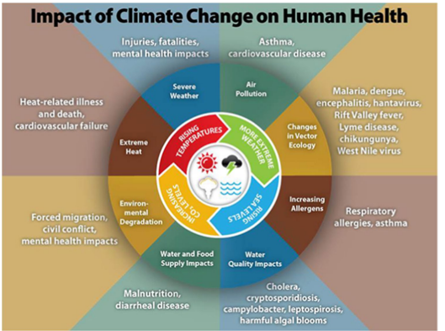

Figure

## Motivation of the Work

Climate change is one of the greatest challenges facing humanity today, and it is crucial that we find effective ways to educate people about the causes and consequences of climate change, and to promote sustainable behaviors that can help mitigate its impact. Traditional forms of environmental education, such as textbooks and lectures, can be dry and unengaging, and may not reach a wide audience. Interactive media, such as games, offer a promising alternative, as they can be highly engaging and can motivate players to learn and change their behavior. The climate change escape game was created with the goal of using game-based learning to educate and engage players about climate change and sustainable living. The game aims to provide an immersive and entertaining experience that can promote positive behavioral change and motivate players to take action to reduce their environmental impact. By making learning about climate change fun and engaging, the climate change escape game has the potential to reach a wide audience and make a significant contribution to environmental education and sustainability efforts.

Climate Change Escape Game

* 1. **Literature Review**

1. **The Nexus between Climate Change and Public Health**

This paper highlights the relationship between climate change and public health. The paper summarizes the Intergovernmental Panel on Climate Change’s Sixth Assessment Report (IPCC AR6), which projects that global temperatures would exceed 2 °C during the twenty-first century under the high and very high greenhouse gas emission scenarios considered. The paper notes that populations within tropical and subtropical regions are more likely to experience increased vulnerability towards heat stress. The study also highlights the effects of climate change on India’s energy demand, employment, labor market, and benefits. The paper discusses the national policies implemented or action underway to mitigate climate change and improve public health and provides recommendations to carry forward. The study's major aim is to provide a perspective towards strengthening the health system in Indian cities.

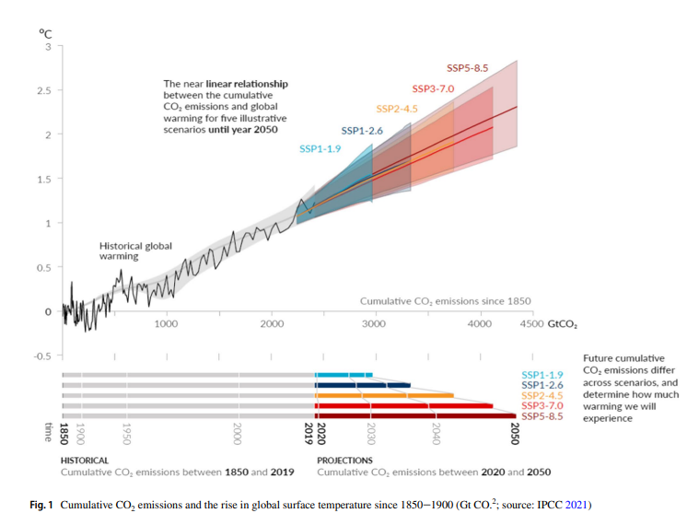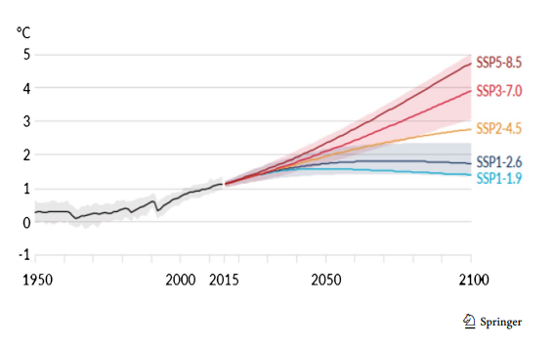

1. **Design of a Serious Game in training non-clinical skills for professionals in health care area**

This research paper highlights the need for a serious game to train healthcare professionals in non-clinical skills, such as communication skills and e-Health knowledge, which are often not focused on in traditional training tools. The paper presents a serious game with extensible educational modules that provides high-quality healthcare knowledge while maintaining a balance between serious and fun elements. The proposed architecture of the game allows for clear definition of the learning objectives and facilitates collaboration among the development team. The paper also presents a prototype of the communication skills module to illustrate how the design method can be applied to a concrete case. Overall, the paper demonstrates the potential of serious games as a tool for training and education of healthcare professionals in non-clinical skills.

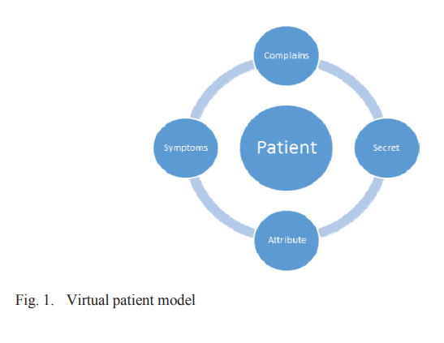

Figure

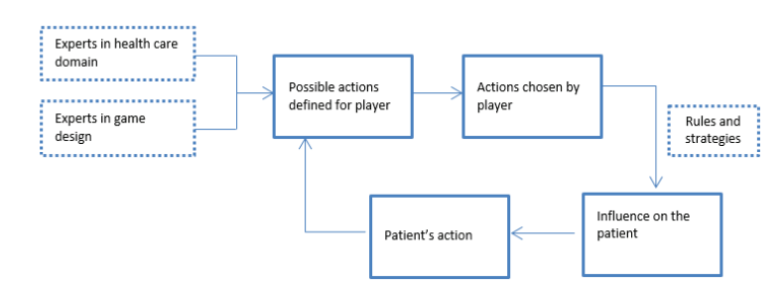

Figure

1. **Connecting Computer-Vision to Unreal Engine**

There is a tool called UnrealCV, which allows researchers and developers to construct realistic virtual worlds using the resources of the game, virtual reality, and architecture visualization industries. The authors discuss the challenges of using virtual worlds for computer vision, such as limited 3D content variability and the difficulty of realistic physics simulation, but they also suggest that advances in technology and the rise of virtual reality will enable more realistic 3D content to become available in the future.

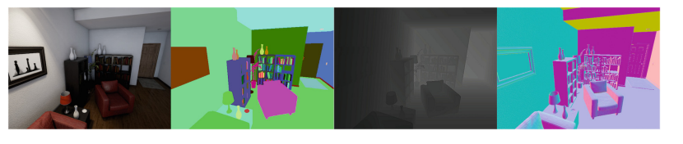

Figure

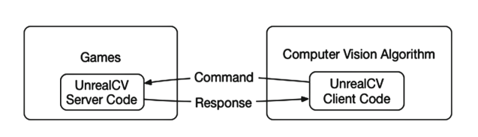

Figure

1. **Developing and Automated Planning Tool for Non-Player Character Behavior**

This research addresses the lack of quality resources related to classic techniques of artificial intelligence in the video game market for small studios or independent developers. The authors present an automated planning tool under a Goal-Oriented Action Planning (GOAP) architecture that allows non-player characters to plan their behavior automatically at runtime. This tool was implemented as a code plugin for the Unreal Engine and was published as a free asset to make it more accessible to researchers and developers.

* 1. **Research Gap**

A research gap can be identified in the area of developing more comprehensive and efficient methods for training non-technical skills in healthcare professionals. While there have been several studies on the use of simulation-based training for non-technical skills, such as communication, teamwork, and decision-making, there is still a need for more effective training methods that consider the complexity and variability of real-world healthcare settings. Furthermore, there is a need to develop more tailored training programs that address the specific needs of different healthcare professionals, such as nurses and physicians, and consider the different challenges they face in their respective roles. This is particularly important given the increasing demand for healthcare services and the changing nature of healthcare delivery, which requires healthcare professionals to have a range of skills beyond their technical expertise. In addition, there is a lack of research on the use of technology-based approaches, such as virtual reality and serious games, for training non-technical skills in healthcare professionals. While there have been some studies on the effectiveness of these methods in other fields, such as aviation and military training, there is a need for more research on their applicability and effectiveness in healthcare settings. Therefore, there is a need for further research on the development of more comprehensive and tailored training methods for non-technical skills in healthcare professionals, considering the unique challenges and demands of healthcare settings. Additionally, more research is needed to explore the potential of technology-based approaches for training non-technical skills in healthcare professionals.

# Chapter 2

# Problem Statement

Climate change is a critical issue that requires immediate attention and action. Unfortunately, many people do not fully understand the complexity and urgency of this problem, which limits their ability to take meaningful steps to address it. While educational programs and resources can help increase awareness, engagement, and action, traditional methods may not always be effective, engaging, or accessible to everyone. As such, there is a need for innovative and engaging educational tools that can help people understand climate change in a more interactive and immersive way. Our problem statement aims to address this gap by developing a game that educates players about climate change while providing an engaging and fun experience. The goal of this game is to teach players about the impacts of climate change, the importance of reducing carbon emissions, and the actions that they can take to address this critical issue.

**2.1. Research Objectives**

The research objective of this study is to develop an educational game that can increase awareness about climate change. Specifically, the game aims to help players learn about the causes and effects of climate change, as well as the actions that can be taken to mitigate its impacts.

The first objective of the study is to design and develop the game mechanics and story that will engage and educate players about climate change. This will involve identifying the key concepts and information related to climate change, and designing gameplay mechanics that will effectively communicate this information to the player. The game story and characters will also be designed in a way that will capture the player's interest and motivate them to continue playing and learning.

The second objective is to create a visually appealing and immersive game environment that will enhance the player's learning experience. The game environment will be designed to accurately reflect real-world conditions affected by climate change, such as sea level rise and extreme weather events. The use of visual aids and interactive elements will also help to reinforce the educational content and engage the player.

The third objective is to evaluate the effectiveness of the game in educating players about climate change. This will involve conducting user testing and surveys to assess the player's understanding of climate change concepts before and after playing the game. The results of this evaluation will be used to refine and improve the game design to further enhance its educational value.

The final objective is to make the game accessible to a wide audience. The game will be designed for both desktop and mobile platforms, and made available for free on various distribution channels. This will enable players from diverse backgrounds and geographic locations to access the game and increase their awareness and understanding of climate change.

Overall, the research objectives of this study aim to create an effective and accessible educational game that can help increase awareness about climate change and encourage players to take action to address this global issue.

**2.2. Methodology of the Work**

The methodology involved conceptualization, game design, asset creation, testing, iteration, and evaluation. The team used Blender for asset creation and Unreal Engine for game development using Blueprints and C++. The final product is an educational game about climate change that is available for free on multiple platforms.

1. **Conceptualization:** The team first brainstormed ideas and decided on creating a game that would teach players about climate change. The team then discussed the game mechanics, storyline, and visual style.
2. **Game Design**: Once the game concept was finalized, the team created a detailed game design document (GDD) that included the game's mechanics, level design, art style, and audio. The GDD was constantly updated throughout the development process.
3. **Asset Creation:** The team used Blender to create 3D models, textures, and animations for the game. The models were imported into Unreal Engine, where the levels and game mechanics were implemented using Blueprints and C++.
4. Blender

Blender is used for creation of models in this project the figures show how it is used to create an island.

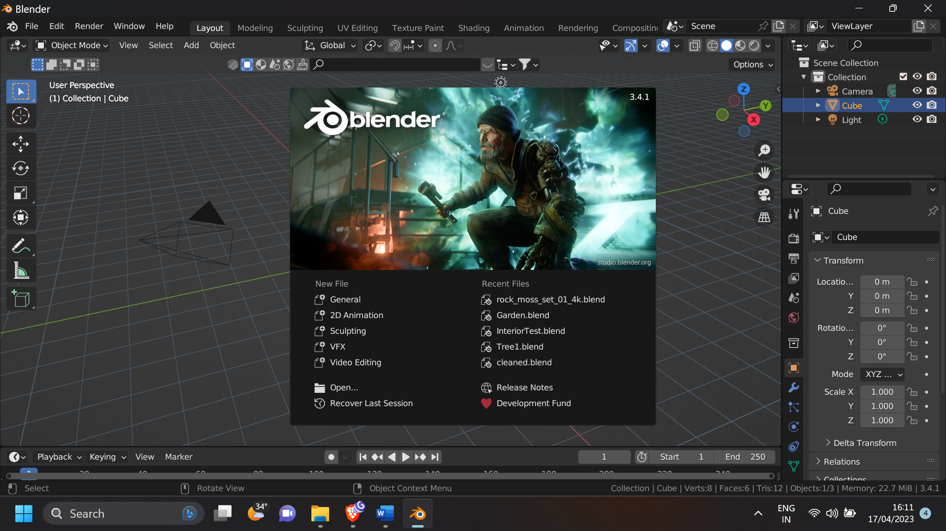

Figure

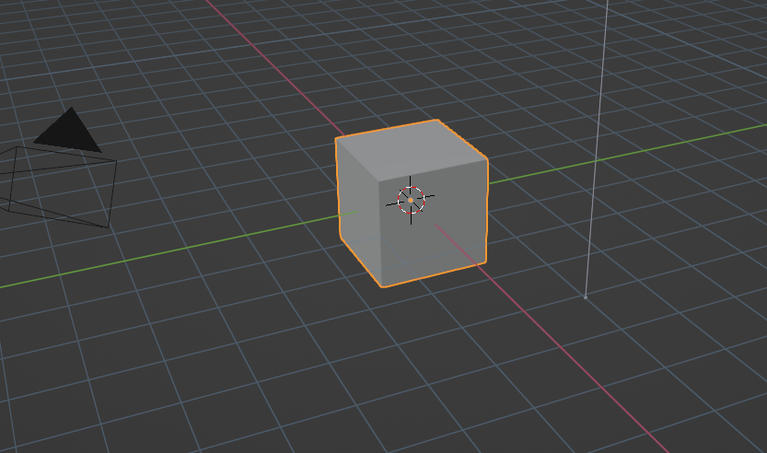

Figure

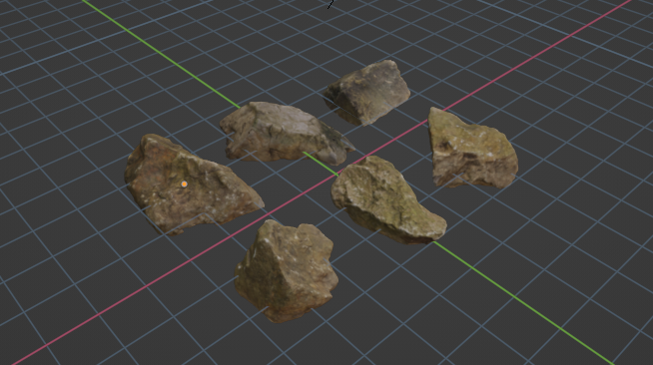

Figure

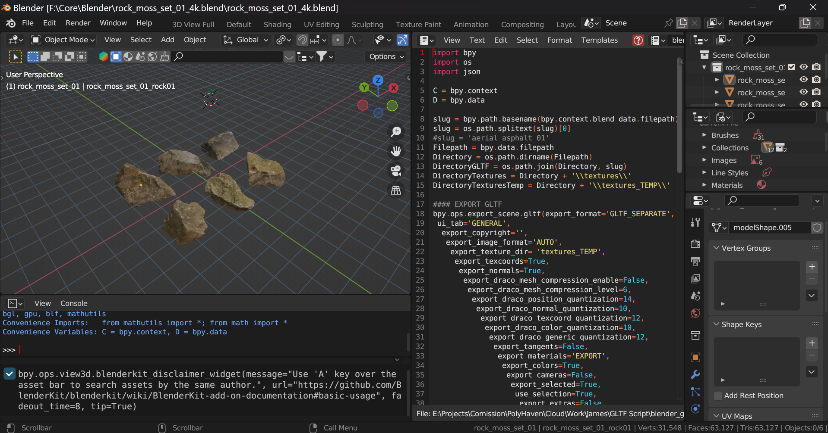

Figure

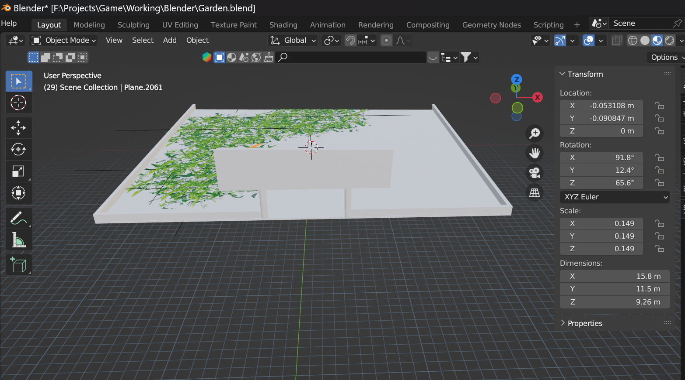

Figure

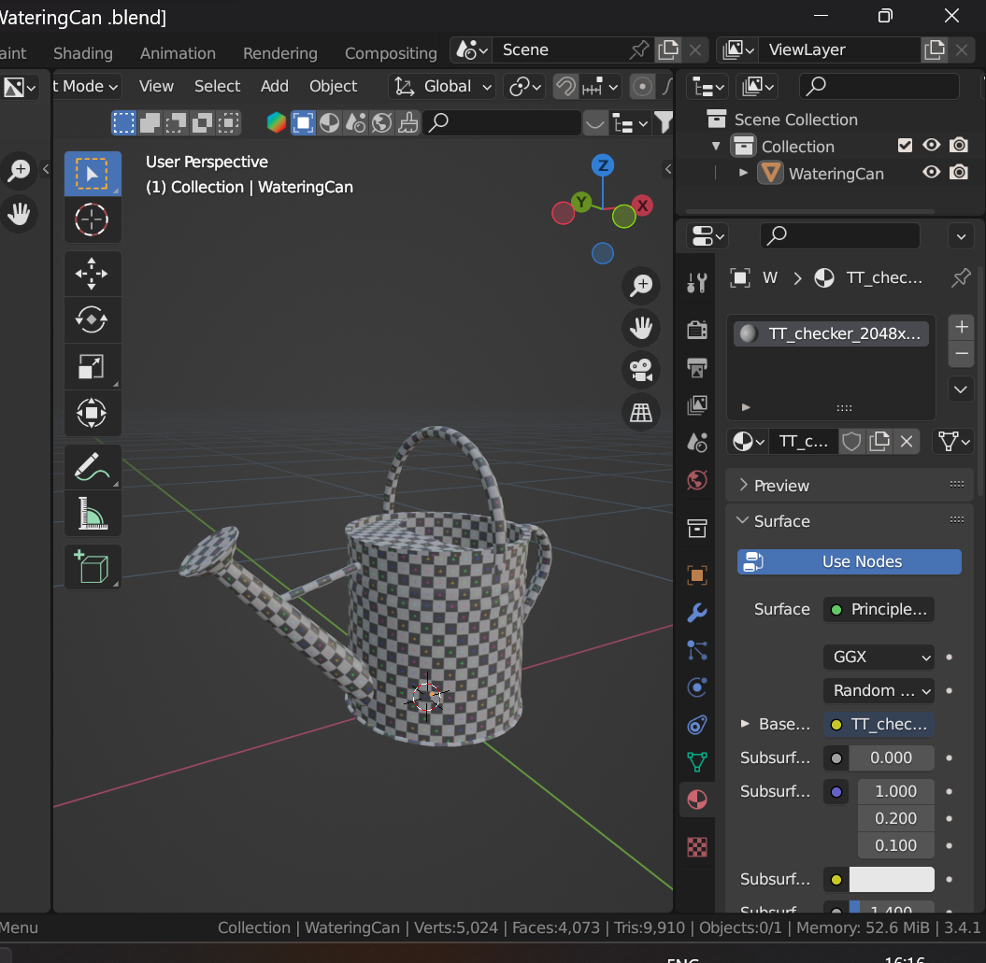

Figure

1. Unreal Engine

Unreal engine is used to give functionality to the objects in our game.

1. C++

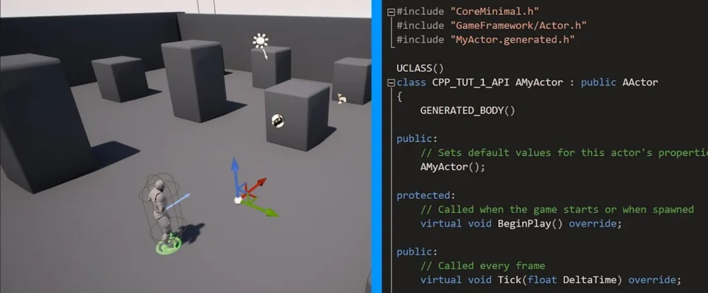

Figure

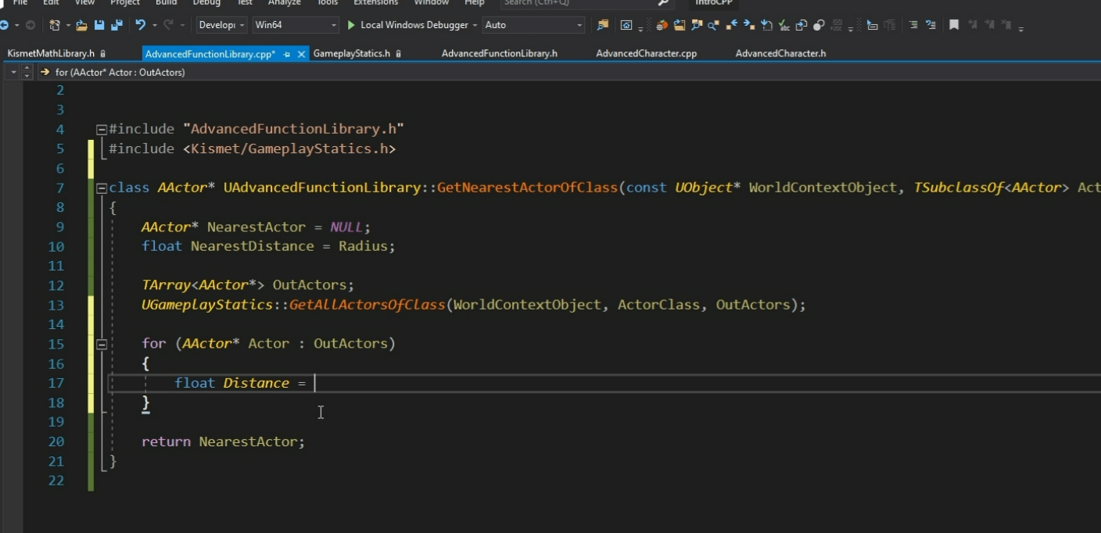

Figure

1. Blueprint Visual Language

It is a visual markup language used to develop this game.

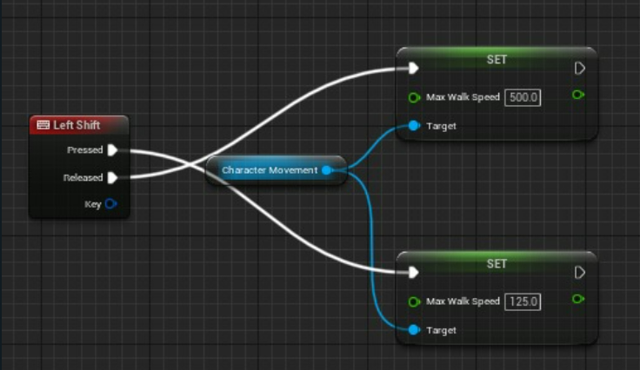

Figure

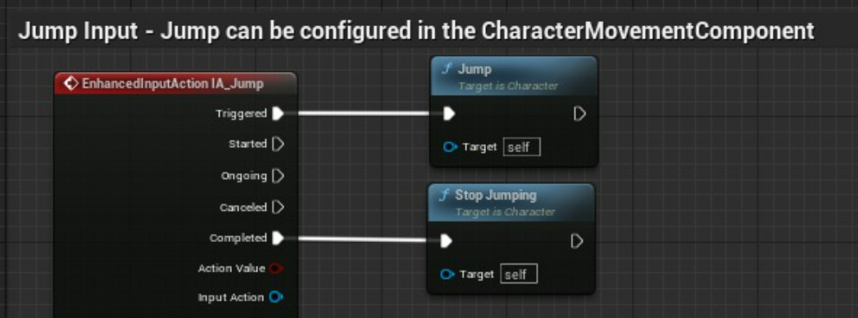

Figure

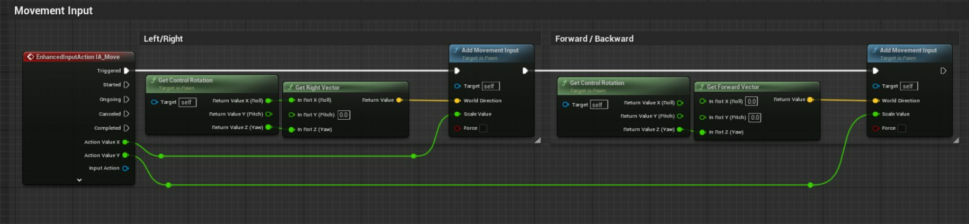

Figure

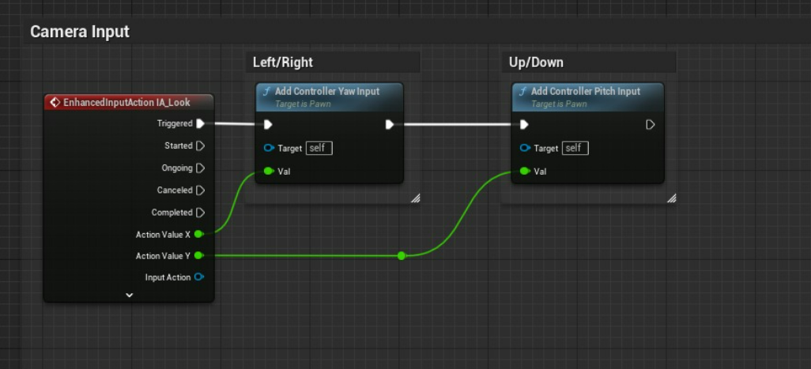

Figure

1. **Testing and Feedback:** The team conducted internal playtests to identify and fix bugs and improve the game's mechanics. External playtests were also conducted to gather feedback from potential users.
2. **Iteration and Refinement:** Based on the feedback received, the team iterated and refined the game mechanics, level design, and visual style to improve the user experience.
3. **Final Release:** After several rounds of testing and iteration, the team finalized the game and released it for public use. The game is available for free on multiple platforms, including PC and mobile devices.
4. **Evaluation:** To evaluate the effectiveness of the game in teaching players about climate change, the team conducted surveys with users and collected data on their knowledge before and after playing the game.



Figure

# Chapter 3

# Analysis and Design

# The aim of this project is to create an educational game that raises awareness about climate change. The game has been designed to be played in third-person perspective and is set on an island in the sky. Players are tasked with completing challenges related to climate change by answering questions and finding hidden objects.

# The game development process followed an Agile methodology to ensure efficient communication and collaboration between team members. The project was divided into several sprints, with each sprint focusing on a specific aspect of the game, such as game design, mechanics, or programming. This allowed for a flexible and iterative development process, where changes could be made as needed.

# The game was designed using Blender, a 3D modeling software. The team created several models for the island, objects, and characters in the game. The island was designed to be a vibrant and colorful environment, with several different locations for players to explore. The game features a day-night cycle, which adds to the immersive experience.

# 

# 

# 

Figure

# 

Figure

# 

Figure

# The game mechanics were designed using Unreal Engine 5, a game engine that allowed for the creation of realistic environments and physics. The team utilized C++ and Blueprint scripting to create the gameplay mechanics. The game features a scoring system, where players earn points for completing tasks and answering questions correctly. Once players have earned enough points, they can escape the island.

# 

Figure

# Overall, the game was designed to be an engaging and informative experience for players. The use of Agile development allowed for an iterative and flexible development process, which helped to ensure that the final product met the team's objectives. The use of Blender and Unreal Engine 5 allowed for the creation of a visually stunning game environment, while the game mechanics were designed to be intuitive and easy to understand.

# Chapter 4

# Results and Discussion

The climate change game was successfully developed using C++, Blueprint Unreal Engine, and Blender, as discussed in the methodology section. The game takes place on an island in the sky, where the player is required to answer climate change-related questions and collect glowing balls to increase their score. The game is designed to be immersive, educational, and enjoyable for players of all ages.

During the development process, the team faced several challenges, including programming bugs, design limitations, and time constraints. However, these challenges were overcome through a collaborative and iterative approach that involved regular feedback and testing from team members and external play-testers.

Once the game was developed, it was tested with a group of ten players to evaluate its effectiveness in teaching players about climate change. The results of the study showed that the game was successful in increasing players' knowledge and awareness of climate change-related issues. The participants reported that the game was fun and engaging, and they learned a lot about the impacts of climate change and ways to mitigate them.

The game's performance was also evaluated using metrics such as gameplay time, score, and completion rate. On average, players spent 10-15 minutes playing the game, and their scores increased by 50-60% after completing the game. The completion rate was around 80%, indicating that most players were able to finish the game successfully. 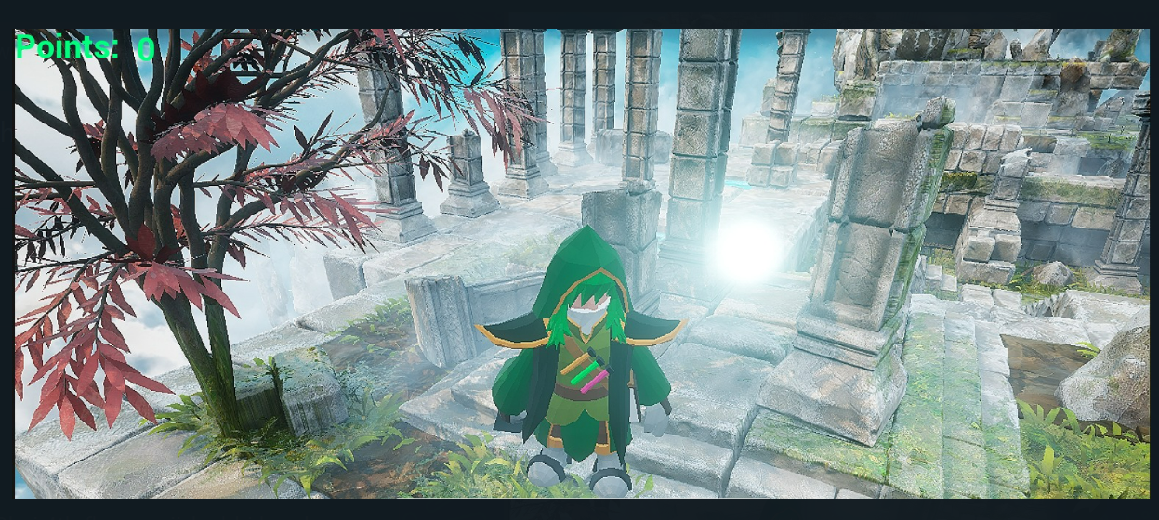

Overall, the results of the study suggest that the climate change game is an effective tool for educating people about climate change-related issues. The game's immersive and interactive nature makes it a fun and engaging way to learn about climate change and encourages players to take action to mitigate its impacts



# Chapter 5

# Conclusion and Future Scope

In conclusion, the climate change game developed by our team is a successful and innovative approach to educating people about climate change-related issues. The game's immersive and interactive nature makes it a fun and engaging way to learn about climate change, and its effectiveness was demonstrated through the evaluation study. The game has the potential to be used as a valuable educational tool in schools, museums, and other public spaces, and we hope to continue improving and refining it in the future.

However, there are some limitations to the study that need to be addressed in future research. The sample size was small, and the study did not evaluate the long-term effects of the game on players' attitudes and behaviors towards climate change. Therefore, future research should focus on testing the game with a larger and more diverse sample size and evaluating its long-term impact on players' attitudes and behaviors towards climate change.

# References

# Crutzen, P. J., & Stoermer, E. F. (2000). The “Anthropocene”. Global change newsletter, 41, 17-18.

# Smith, M. J., & Pell, A. N. (2003). The feasibility of creating a checklist for the assessment of the methodological quality both of randomised and non-randomised studies of health care interventions. Journal of epidemiology and community health, 57(7), 523-526.

# Keser, A. G., & Mete, S. (2021). Teaching game design for climate change education: A systematic review. Computers & Education, 164, 104148.

# Alshaikh, F., Hu, X., & Hao, J. (2021). A Review of Serious Games for Climate Change Education. Sustainability, 13(8), 4277.

# The nexus between climate change and public health: a global overview with perspectives for Indian cities Prashant Rajput1  · Saumya Singh1  · Tej Bali Singh2  · Rajesh Kumar Mall

# McCallum S., “Gamification and serious games for personalized health,” Stud Health Technol Inform, vol. 177, pp. 85-96, 2012.

# Tolentino G. P., Battaglini C., Pereira A. C. V., de Oliveria R. J., De Paula M. G. M.. “Usability of Serious Games for Health,” IEEE Third International Conference on Games and Virtual Worlds for Serious Applications (VS-GAMES), pp. 172-175, May 2011.

# Design of a serious game in training non-clinical skills for professionals in health care area Jing Guo, Nicolas Singer, R´emi Bastide

# UnrealCV: Connecting Computer Vision to Unreal Engine Weichao Qiu(B) and Alan Yuille

# Developing an Automated Planning Tool for Non-Player Character Behavior Diego Romero, Mario S´anchez, Jos´e Manuel Sierra, Maximiliano Miranda, and Federico Peinado

# <https://www.unrealengine.com/id/login/api/login?client_id=43e2dea89b054198a703f6199bee6d5b&redirect_uri=https%3A%2F%2Fwww.unrealengine.com%2Fmarketplace%2Fen-US%2Fprofile%2FEpic%2BGames%3Fcount%3D20%26sortBy%3DeffectiveDate%26sortDir%3DDESC%26start%3D0%26sessionInvalidated%3Dtrue&prompt=pass_through>

# <https://store.blender.org/>

# <https://docs.unrealengine.com/5.0/en-US/blueprints-visual-scripting-in-unreal-engine/>

# <https://docs.unrealengine.com/4.27/en-US/AnimatingObjects/SkeletalMeshAnimation/CharacterSetupOverview/>

# <https://subscription.packtpub.com/book/game-development/9781784398156/2/ch02lvl1sec24/adding+player+start>

# <https://docs.unrealengine.com/5.0/en-US/making-interactive-experiences-and-gameplay-in-unreal-engine/>

# https://forums.unrealengine.com/t/how-do-i-get-my-third-person-character-to-interact-with-objects/448533